|  |  |
| --- | --- |
|  | **MATHEMATICS:SPECIALIST 3 & 4**  **SEMESTER 2 2017**  **TEST 4**  **Calculator Free** |
|  |  |

Reading Time: 2 minutes Time Allowed: 25 minutes

Total Marks: 22

1. (a) 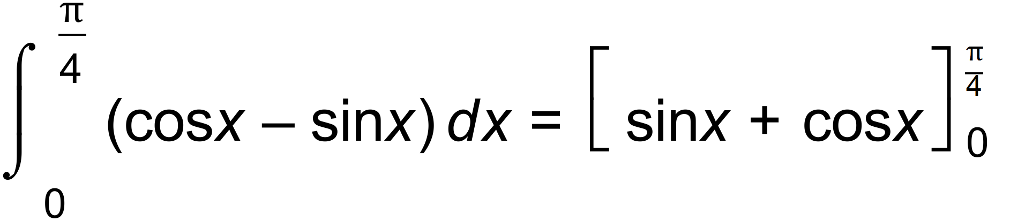 ✓

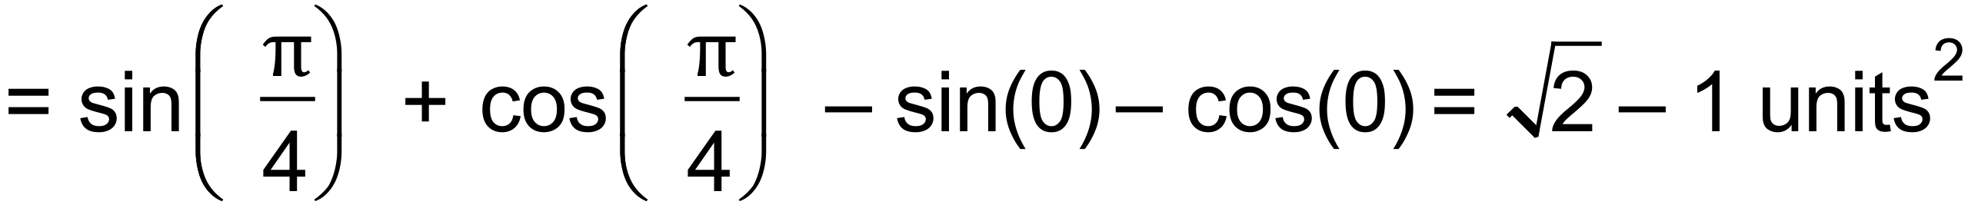 ✓

(b) 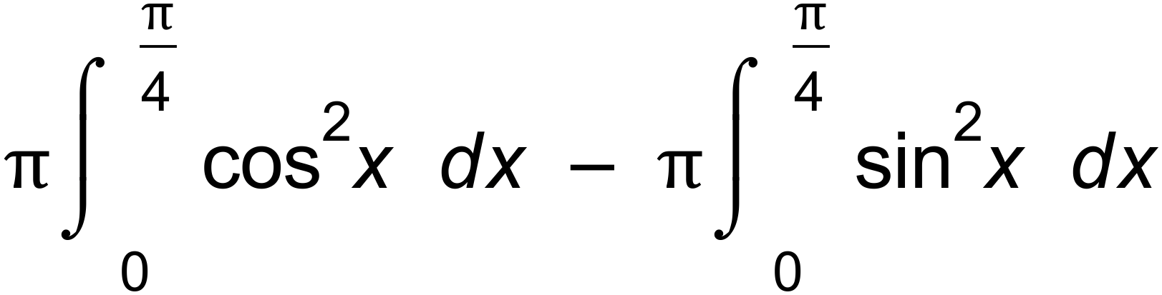 ✓

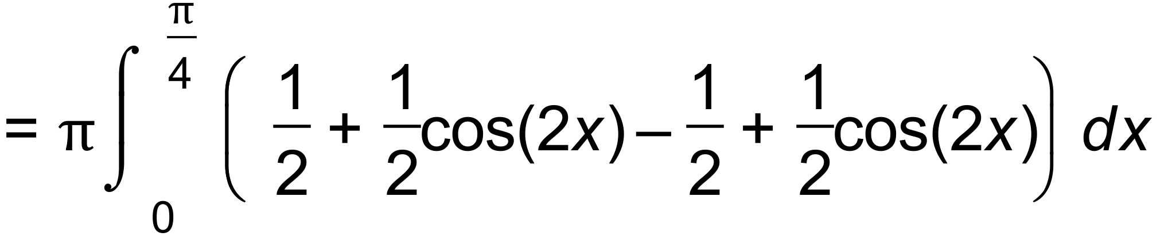 ✓

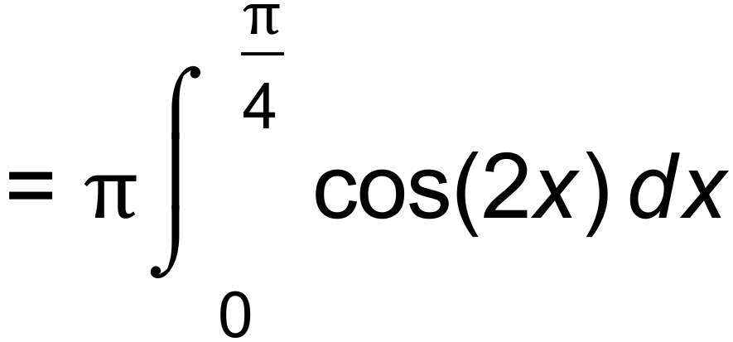 ✓

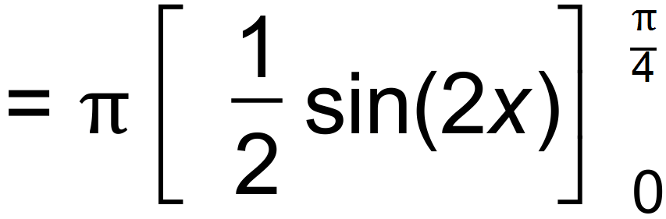 ✓

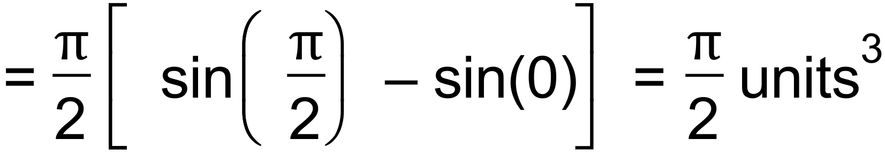 ✓ [7]

**Question 2 (15 marks)**

Determine the following integrals.

1.  (2 marks)

|  |
| --- |
| **Solution** |
|  |
| **Specific behaviours** |
| 🗸 recognises that numerator is proportional to derivative of numerator  🗸 uses natural log with a constant |

1.  (3 marks)

|  |
| --- |
| **Solution** |
|  |
| **Specific behaviours** |
| 🗸 uses double angle formula for cosine  🗸 integrates one term correctly  🗸 integrates all terms correctly |

Determine the following integrals with the given substitution.

1.  (3 marks)

|  |
| --- |
| **Solution** |
|  |
| **Specific behaviours** |
| 🗸 changes variable to *u* in integral  🗸 antidifferentiates with respect to *u*  🗸 expresses in terms of *x* |

1.  (3 marks)

|  |
| --- |
| **Solution** |
|  |
| **Specific behaviours** |
| 🗸 changes variable to *u* in integral  🗸 changes limits to *u* values  🗸 determines definite integral |

(e) Using partial fractions, or otherwise, determine $\int{\frac{x-19}{(x+1)(x-4)}}dx$. (4 marks)

|  |
| --- |
| **Solution** |
| $A\left(x-4\right)+B\left(x+1\right)=x-19⇒A+B=1, B-4A=-19$ Solving gives |
| **Specific behaviours** |
| ✓ writes equations for A and B  ✓ determines A and B  ✓ integrates both fractions correctly  ✓ includes constant of integration |

|  |  |
| --- | --- |
|  | **MATHEMATICS:SPECIALIST 3 & 4**  **SEMESTER 2 2017**  **TEST 4**  **Calculator Assumed** |
|  |  |

Reading Time: 2 minutes Time Allowed: 30 minutes

Total Marks: 28

Question 3 (12 marks)

A small body is projected upwards from the top of a hill with an initial velocity of 32 ms-1 at an angle of 60° to the horizontal. The hill slopes downwards at a constant angle of 30° to the horizontal. Let the origin $O$ of a cartesian coordinate system be the top of the hill, with $i$ a unit vector in the positive $x$ direction and $j$ a unit vector in the positive $y$ direction. Displacement is measured in metres and time in seconds.

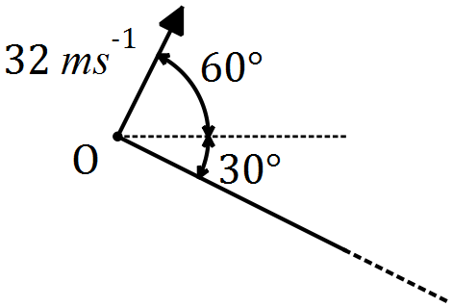

(a) Show that the initial velocity of the body is $16i+16\sqrt{3}j$. (1 mark)

|  |
| --- |
| **Solution** |
| $$v(0)=32\cos{60}i+32\sin{60}j \\ =16i+16\sqrt{3}j$$ |
| **Specific behaviours** |
| ✓ uses trig ratios |

The acceleration of the body, $t$ seconds after projection, is given by $a=-0.2ti+\left(0.2t-10\right)j$**.**

(b) Determine an expression for the position vector of the body after $t$ seconds. (3 marks)

|  |
| --- |
| **Solution** |
| $$v=\left(16-\frac{t^{2}}{10}\right)i+\left(16\sqrt{3}+\frac{t^{2}}{10}-10t\right)j$$ $$r=\left(16t-\frac{t^{3}}{30}\right)i+\left(16\sqrt{3}t+\frac{t^{3}}{30}-5t^{2}\right)j$$ |
| **Specific behaviours** |
| ✓ integrates acceleration  ✓ uses initial velocity for constant  ✓ integrates velocity |

(c) Determine the time at which the body lands on the hillside. (3 marks)

|  |
| --- |
| **Solution** |
| $$\frac{i\text{-coeff}}{j\text{-coeff}}=\tan\left(-30°\right) \\ 16\sqrt{3}t+\frac{t^{3}}{30}-5t^{2}=\left(16t-\frac{t^{3}}{30}\right)×\tan\left(-30°\right) \\ t=7.551 \text{s}$$ |
| **Specific behaviours** |
| ✓ uses ratio of coefficients and tangent of slope  ✓ writes equation using position coefficients  ✓ solves equation |

(d) Calculate the distance of the body from $O$ at the instant it lands. (2 marks)

|  |
| --- |
| **Solution** |
|  |
| **Specific behaviours** |
| ✓ determines position  ✓ calculates magnitude |

(e) Determine the maximum vertical height attained by the particle above the hillside.

(3 marks)

|  |
| --- |
| **Solution** |
| $$h=16\sqrt{3}t+\frac{t^{3}}{30}-5t^{2}+\tan\left(30\right)t \\ \frac{dh}{dt}=\frac{3t^{2}-300t+490\sqrt{3}}{30} \\ \frac{dh}{dt}=0⇒t=2.914 \text{s} \\ h\left(2.914\right)=40.8 \text{m}$$ |
| **Specific behaviours** |
| ✓ forms equation for height above hillside  ✓ solves equation for maximum  ✓ determines height |

4. (a) 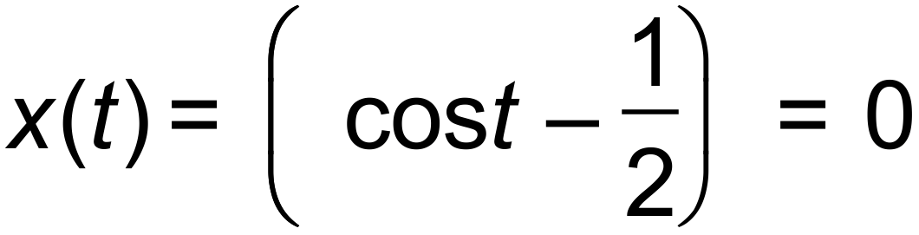

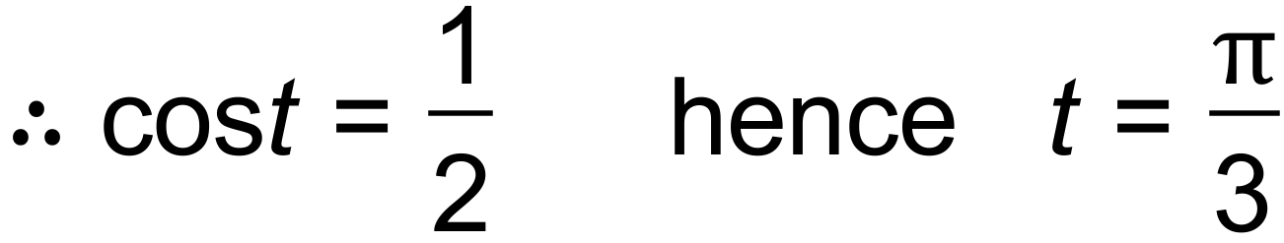 ✓

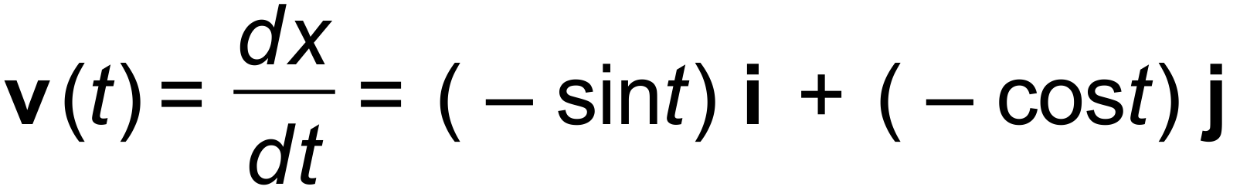 ✓

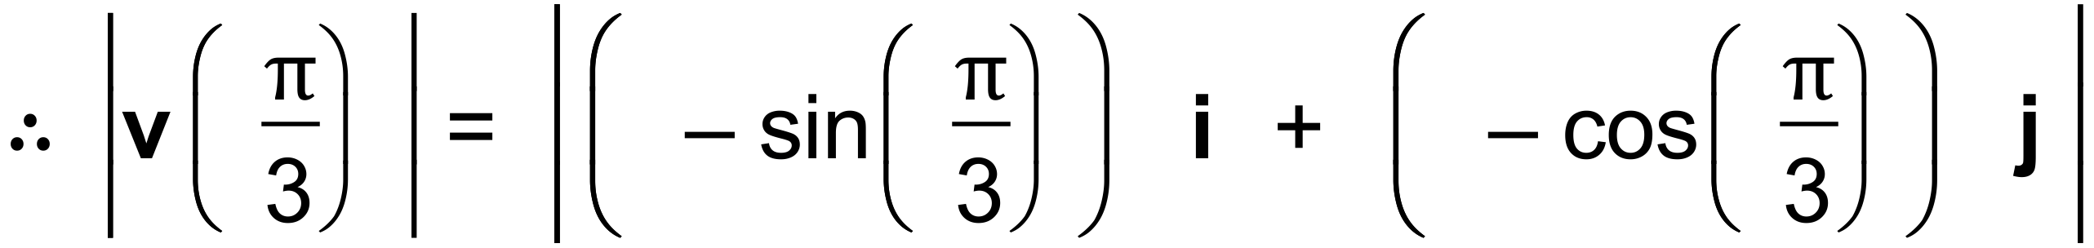 ✓

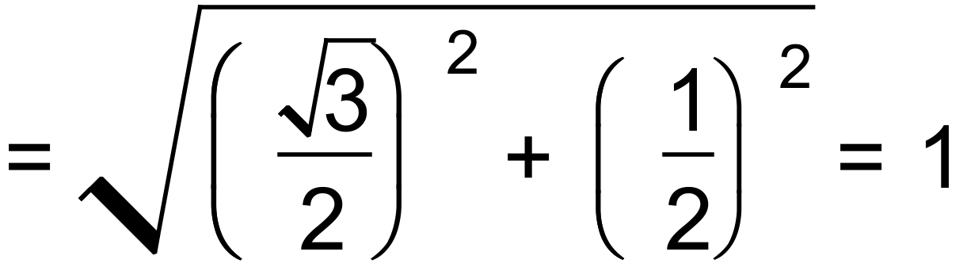 units/s ✓

(b) 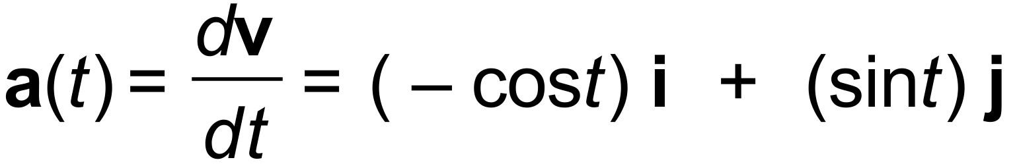 ✓

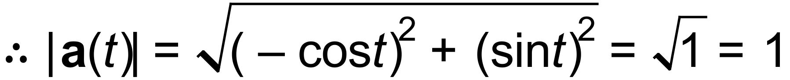 unit/s2 ✓

(c) 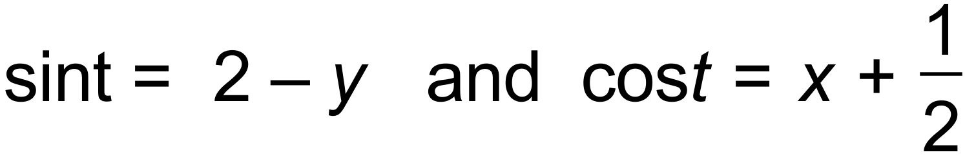

since 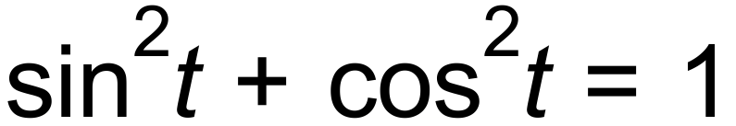

then 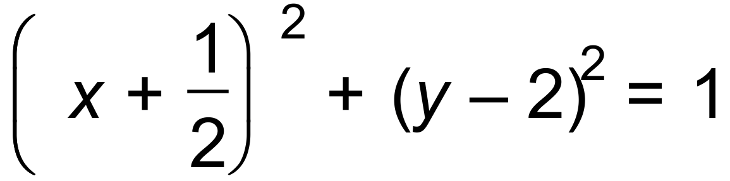 ✓

the path is a circle centred at 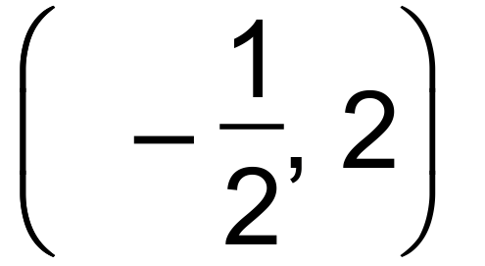 of radius = 1 unit ✓ [8]

Question 5 (8 marks)

(a) Sketch the graph of $y=\frac{2x+1}{x+1}$ on the axes below. (2 marks)

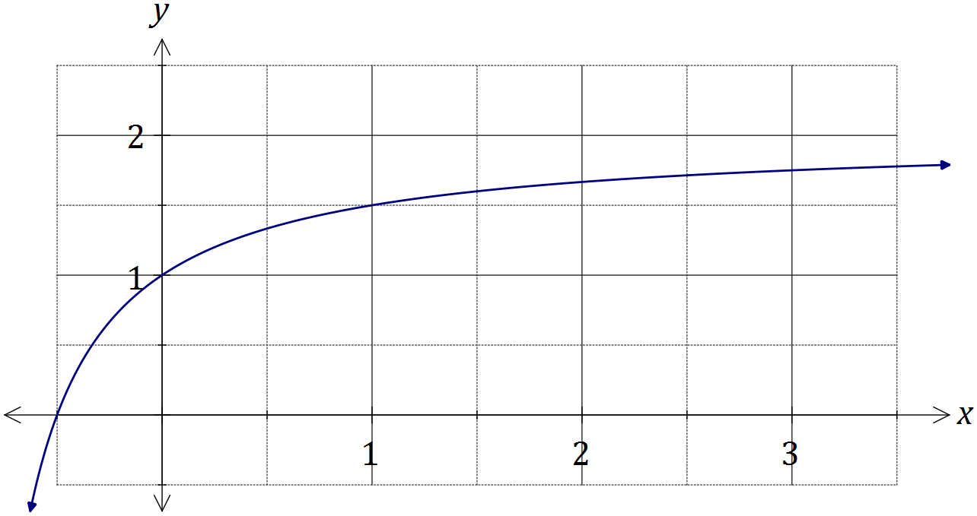

|  |
| --- |
| **Solution** |
| See graph |
| **Specific behaviours** |
| ✓ axes intercepts and (1, 1)  ✓ smooth curve |

Simpson's rule is a formula used for numerical integration, the numerical approximation of definite integrals. When an interval $[a_{0}, a_{n}]$ is divided into an even number, $n$, of smaller intervals of equal width $w$, the bounds of these smaller intervals are denoted $a_{0}, { a}_{1}, a_{2},…, a_{n-1}, { a}_{n}$. Simpson's rule can be expressed as follows:

$$\int_{a_{0}}^{a_{n}}{f(x)}dx=\frac{w}{3}(B+2E+4O)$$

where $B=f(a_{0})+f(a_{n})$, $E$ is the sum of the values of $f\left(a_{k}\right)$ where $k$ is even and $O$ is the sum of the values of $f\left(a_{k}\right)$ where $k$ is odd.

(b) Use Simpson's rule with $n=6$ to evaluate an approximation for $\int_{0}^{3}{\frac{2x+1}{x+1}}dx$, correct to four decimal places. (4 marks)

|  |
| --- |
| **Solution** |
| $a_{0}=1, a_{1}=\frac{4}{3}, a_{2}=\frac{3}{2}, a_{3}=\frac{8}{5}, a_{4}=\frac{5}{3}, a_{5}=\frac{12}{7}, a_{6}=\frac{7}{4}$ $B=\frac{11}{4}, E=\frac{19}{6}, O=\frac{488}{105}$ $\frac{1/2 }{3}\left(\frac{11}{4}+2×\frac{19}{6}+4×\frac{488}{105}\right)=\frac{11623}{2520}≈4.6123$ |
| **Specific behaviours** |
| ✓ calculates ordinates  ✓ calculates B, E and O  ✓ evaluates using rule  ✓ accurate to 4 dp |

(c) Determine the exact value of $\int_{0}^{3}{\frac{2x+1}{x+1}}dx$ and hence calculate the percentage error of the approximation from (b). (2 marks)

|  |
| --- |
| **Solution** |
| $\int_{0}^{3}{\frac{2x+1}{x+1}}dx=6-2\ln{2}$. Hence $\frac{\left(\left(6-2\ln{2}\right)-\frac{11623}{2520}\right)}{6-2\ln{2}}×100≈0.03\%$ error. |
| **Specific behaviours** |
| ✓ calculates exact value  ✓ calculates % error |